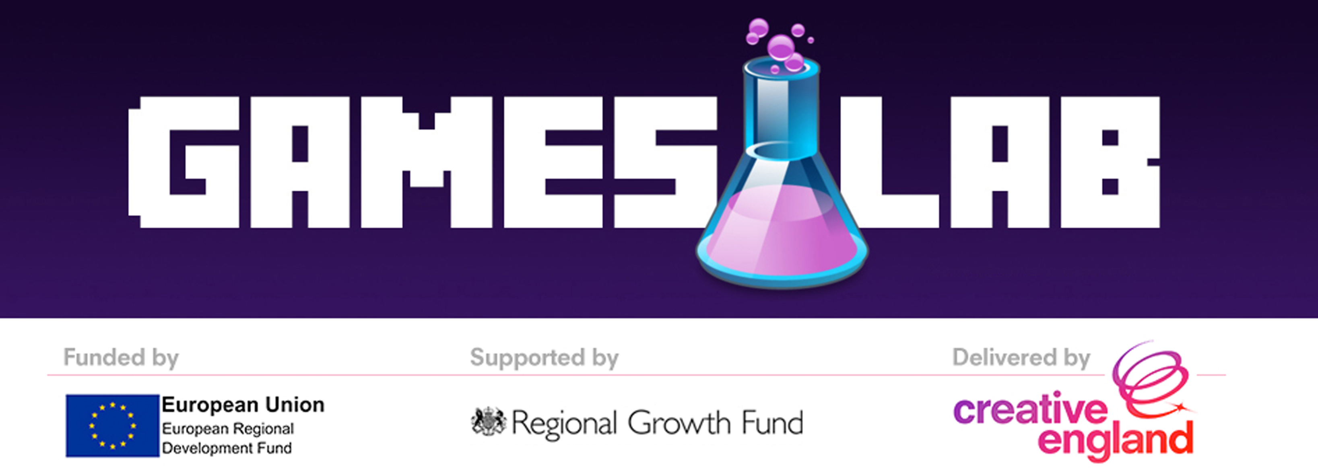
GamesLab
GDC 2017 Application Form

Application Guidance: January 2017

GamesLab: GDC 2017
Creative England GamesLab

Creative England operates with the core purpose of supporting the sustainable growth of independent creative businesses, and the talent that feeds them, in every part of England outside of London.

Creative England’s GamesLab is a programme of investment and support, designed to aid and sustain the growth of a region’s burgeoning games industry, through the development of innovative games and IP. Working with emerging and established companies, the GamesLab Programme aims to create the conditions necessary for the region’s most innovative and commercially astute games companies to flourish.

GamesLab Leeds is intended to stimulate the development and growth of the games industry in the Leeds City Region by supporting companies with demonstrable high-growth potential. By coupling investments with business support in the form of one-to-one mentoring and group workshops, we endeavour to offer our grant recipients the best possible chance of success

The focus of the GamesLab programme is to foster Research, Development and Innovation in the sector.

GDC 2017 Trade Mission

The GamesLab GDC 2017 Trade Mission offers regional businesses the opportunity to attend the Game Developers Conference (GDC) in San Francisco from February 27th to March 3rd 2017. GDC is the world’s largest and longest-running professional-only game industry event. GDC attracts over 24,000 attendees, and is the primary forum where programmers, artists, producers, game designers, audio professionals, business decision-makers and others involved in the development of interactive games gather to exchange ideas and shape the future of the industry.

Through the GamesLab programme, Creative England is able to fund four businesses to join our delegation and attend the conference. This package of support would include:

- A Main Conference + VRDC Pass (for 1 representative per successful business)
- Return Flight from UK to San Francisco, USA. Flying out 26th February and flying back on 4th March *
- Up to 6 nights Accommodation*
- The GamesLab team will organise a schedule of meetings for delegates with a host of publishers, platform holders, and investors. This aspect of the trip will allow delegates to networks with industry professionals whom could impact the long-term success of the delegates’ project and / or business.

* Flights will be direct where possible, and accommodation will be booked through the official GDC housing partner where possible

IMPORTANT: You will be notified in writing once your application is successful and your place is reserved. If you accept the placement at this stage, you will be liable to refund any costs incurred in the event that you cancel thereafter.

Eligibility

This programme is s open to companies who:

- are an SME registered at Companies House. For advice on business types, please visit the European Commission Website and an online “SME Checker” paying particular attention to the thresholds for number of employees, turnover, and permissible amount of ownership by a parent company.
http://ec.europa.eu/enterprise/policies/sme/facts-figures-analysis/sme-definition/index_en.htm

- are registered at trading in the Leeds City Region. For the purpose of the GamesLab programme includes nine local authorities; Bradford, Calderdale, Craven, Harrogate, Kirklees, Selby, Wakefield, York and North Yorkshire County Council

- are currently developing computer games or games related products / services

- can clearly demonstrate that joining the GDC Trade Mission will have a beneficial impact on their specific project or business

The Creative England GamesLab programme operates under ‘De Minimis’ State Aid rules. This means a private company cannot receive over €200,000 worth of public sector support granted under ‘De Minimis’, from whatever source in any three year rolling period. As part of the application process, applicants will be asked to list any State Aid received so we can check it does not exceed the ‘De Minimis’ threshold. For the avoidance of doubt, SEIS investment does contribute to a company’s overall ‘De Minimis’ State Aid allowance.

We are particularly interested in hearing from companies that are:

- working on a game (or game-related product / service ) that offers something fundamentally new and innovative to the market, in terms of either technology, functionality or design
- involved in the Research and Development of new and emerging technologies ( VR, AR, Wearable Tech, etc. )
- developing projects in collaboration with Research and Development Enterprises (Enterprises whose primary focus is Research and Development - which includes Institutes of Further and Higher Education)

Timeline
The deadline to complete this application form is Midnight on 19th December 2016. Please submit your completed application form to ella.waving@creativeengland.co.uk

Applications will be reviewed and processed internally by Creative England. Successful applicants will be informed of their reserved place by 13th January 2017

The application
To apply, please complete the application form below and return it to ella.waving@creativeengland.co.uk.

Alongside your application please provide any available assets, video, screengrabs etc to demonstrate your project

Q1. Eligibility

Please tick to confirm that the applicant company;
- is an SME registered at Companies House
- is registered and trading in the Leeds City Region
- is currently developing computer games or games-related products/services
- can clearly demonstrate that joining the GDC Trade Mission will have a positive, beneficial impact on the product or service in development

Q2. Company Name

Q3. Company Address

Q4. About the applicant (please complete details for the person applying to join the delegation )
- Contact Name
- Position within company
- Email Address
- Contact Number

Q5. Please provide details on your business; What you do, your existing products / services and long-term ambitions
>> Insert Here <<

Q6. Please provide a detailed summary of the game or game related product/service that you are currently developing. Please also forward any assets in your email when submitting your application. Please include details of:
- release platforms and expected release dates
- any partners, collaborators or publishers already attached to the project

Q7. Please describe how your project demonstrates innovation in terms of technology, functionality or design

Q8. Please outline in detail how and why joining the delegation to GDC will benefit your project and / or your business

Q9. Do you currently have a pending application for a grant or loan from Creative England?

Yes/No

Q10. Have you received funding from Creative England in the past 3 years?

Yes/No

>> If Yes, please provide details here <<

Q11. Please confirm the amount, and source, of any State Aid your company has received over the past 3 years. If you are in doubt about how to accurately calculate this, we advise you seek independent, professional advice

