14-18 NOW WWI Centenary Art Commissions
Interactive content co-commission

Application Guidelines

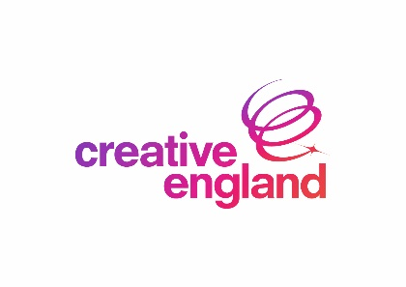

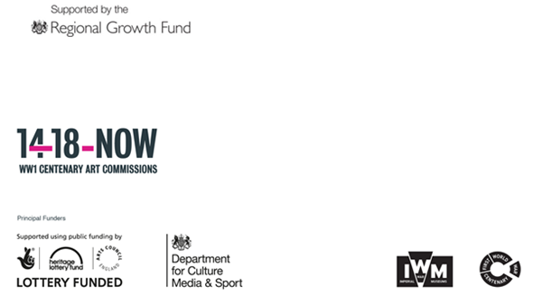

Full Application Form Guidelines

Please read this document along with the Interactive Content Co-commission Project FAQs and Interactive Content Co-commission Creative Brief.

Background Information

Overview, aims and objectives

Creative England operates with the core purpose of supporting the sustainable growth of independent creative businesses, and the talent that feeds them, in every part of England outside of London. Among other objectives it intends to stimulate development in creative and digital SME’s working in cross-platform content and services. It supports companies in the English regions that want to innovate and grow and be more competitive within the digital communications, TV, film, games, interactive and mobile content sectors.

The Regional Growth Fund is delivered by the UK Government’s Department for Business, Innovation and Skills. The primary objective of the Regional Growth Fund is the support of eligible projects and programmes that are raising private sector investment to create economic growth and lasting employment.

- 14-18 NOW WW1 Centenary Art Commissions
14-18 NOW is working with leading artists around the UK and internationally to commission new work in response to the First World War and the wider upheavals and developments of 1914-18.

Perceptions of the First World War have been shaped to a great extent by the artists of the time – the musicians, poets, writers, painters, photographers, and film-makers who reflected on the war and its effects on individuals and society. One hundred years later, the aim is to invite contemporary artists to look afresh at the First World War and the wider social, political, scientific and technological developments of the period and their impact over the century that followed and the world around us today. The Cultural Programme will centre around three key moments: summer 2014 (anniversary of declaration of war), spring/summer 2016 (Battle of the Somme) and autumn 2018 (centenary of the Armistice).

The Interactive Content Co-commissioning Project will invite the creative industries to reflect on the First World War from the perspective of today alongside other contemporary artists and submit proposals for the development of a new and original interactive content [for use on mobile and tablet devices and potentially PC distribution] that will respond to the First World War and the developments of the period around the world stimulated by the conflict.

Interactive content could be:
- Browser content / tool(s)
- Mobile app or game

- The Funding
The Project Fund totals £82,000.

Following a competitive application and pitch process the intention is to select one winning project for full product development, for which an investment totalling £82,000 is being made available. This substantive development funding will be awarded to the successful applicant on a revenue-share basis, meaning it is to be repaid from any revenues generated from the commercial exploitation of the selected project.

All funds are subject to the availability of funding and are discretionary. There is no guarantee that any applicant will be offered funding even if the applicant and project are eligible.

Who can apply?

In line with the Regional Growth Fund objectives and criteria, this funding is only available to companies based in the English regions outside of Greater London. Please note that this funding is unfortunately not available to local authorities or academic institutions.

Your company should aspire to grow through your proposed activity and evidence of your capacity to support, nurture and exploit this growth potential will be essential to making a compelling proposal. You will need to demonstrate a clear response to the Interactive Content Co-commission Creative Brief.

- The Application Process

The application process has two stages. Stage one involves filling in an online application form. Creative England and 14-18 NOW will jointly select up to five applications from this stage to prepare a presentation to be considered at Stage two of the process. Stage two involves a live pitch and Q&A to a judging panel who will make the final decision on which project is deserving of up to £82,000 of substantive product development funding.

Stage One
Applicants can apply from Monday 10 August 2015. There are three steps to doing so:

- Download the Interactive Content Co-Commission FAQs and read carefully together with these Guidelines.

- Fill in the online application form to tell us a bit about your organisation, your project idea, and how it will meet 14-18 NOW’s objectives. You will be expected to develop a more detailed proposal if you are selected to pitch your idea to Creative England and 14-18 NOW at Stage Two.

- Submit your application online. Once you have registered online you can start your application, save your work and come back at any time to complete it. The deadline for submitting your application is Friday 18 September 2015, and applicants will be notified of the outcome by Friday 2 October 2015.

Once we have received your application it will go through a formal eligibility and assessment process. This will be undertaken by Creative England with input from 14-18 NOW who will consider, amongst other things:

- The viability and track record of the applicant company
- The quality of the creative elements
- Cost efficiency
- The viability of your business plan
- The likelihood of growth and jobs creation and the timeliness of these outcomes
- The market viability of the project and the likelihood of it proceeding to production
- The likely long-term economic impact of the project should it proceed to production and the fit with the strategic aims of the WWI Centenary Art Commissions Programme
- The commercial competence of the proposal and business experience of the applicant company

We will use the information you provide us in your application to make a decision and only up to five projects in the stage one application round will be selected to proceed to stage two.

Stage Two
Stage Two will involve a pitching session held week commencing Monday 12 October 2015 (date and location to be confirmed).

Finalists will have 45-minutes to present their idea and take part in a Q&A session with the panel, which will include members of the Creative England senior executive team and the 14-18 NOW team.

The panel will select one winning project and the successful company will be notified in writing by Friday 23 October 2015.

If your application (and subsequent due diligence) is successful you will be invited to enter into a development funding agreement which will set out the amount of financial assistance to be provided and the conditions under which it will be made available.

The panel’s decision is final and there is no right of appeal against its decision. However should you have any concerns about any aspect of the application process Creative England has a detailed Complaints and Appeals Procedure in place. Details are available on request.

Filling in the Application Form

- Section: The Applicant Company
We may use the information you provide in this section for due diligence and contract preparation purposes, therefore please ensure all company information is accurate. Please note that this funding is strictly targeted at small and medium enterprises (SME) as defined by the European Commission.

An SME will feature the following characteristics:

Has less than 250 employees
- Has either (1) an annual turnover not exceeding €50 million (approximately £39 million) or (2) an annual balance sheet total not exceeding €43 million (approximately £33.5 million);
- 25% or more of the capital or the voting rights are not owned by one enterprise, or jointly by several enterprises, that fall outside this definition of an SME.

For further advice on business types please visit the European Commission Website for guidance and an online “SME Checker”.

- Section: Your Proposal

What does your organisation do?
You may wish to highlight achievements that are particularly relevant to the project proposal.

Describe the project team
Please only include details of staff members who will be working on the project. Please attach the CVs of key project staff in the attachment section of the application form.

What is your proposal?
Please describe your proposal to the Interactive Content Co-commissioning Project detailing how your web, mobile, game or tablet application will respond to the First World War and the developments of the period around the world stimulated by the conflict. Tell us about the business opportunity or market failure that you are seeking to address with this project proposal, making reference to the 14-18 NOW WWI Centenary Art Commission Programme. This might include independent evidence which should be noted/ referenced where applicable.

Please outline the key elements of production and delivery
Please tell us about the format, platforms, and partners etc. that you are planning to use. What is your approach to project management? Please provide a full cost breakdown and timeline.

- Section: Timescales and Deliverables

When do you propose to start your activity?
Please specify the start date of your proposed project. The project must start in November 2015. In order for the ‘proof of concept’ grant to be paid in advance of incurring costs you will need to indicate when expenditure is likely to start.

When do you propose to finish your activity?
Please specify the end date of your proposed project. The fully developed project must be completed by June 2016.

- Section: Finance

What are the costs of the proposed project?
The costs should tally with your project budget previously described in ‘key elements of production and delivery’.

Have you received any state aid in the last 3 years?
Funding from the Interactive Content Co-commission Project constitutes state aid. Unless otherwise exempt a private company cannot receive over €200,000 worth of state aid from whatever source in any three-year rolling period (the so-called ‘de minimis’ exemption). Please therefore confirm the amount of state aid you have received in the past 3 fiscal years. Please state the amount in Euros.

For further advice on state aid and the de minimis and other potential exemptions please use visit the Department of Business, Innovation and Skills website: http://www.bis.gov.uk/policies/europe/state-aid/de-minimis-aid-regulations

- Section: People

How many employees does the company have?
Please note that relevant definitions are:
- Full-time job (FT) = 30 hours or more per week;
- Part-time job (PT) = more than 15 hours, but fewer than 30 hours per week;
- Two part-time jobs of 15-29 hours per week = one full-time equivalent (FTE).

Once you are happy that all details on the application form are correct, click ‘Submit Application’.

A confirmation e-mail will automatically be sent to you.

For further guidance please contact the Business Investment Team at Creative England via email at business@creativeengland.co.uk and we will respond to your enquiry as soon as possible.

