14-18 NOW WWI Centenary Art Commissions
Interactive content co-commission

Creative Brief

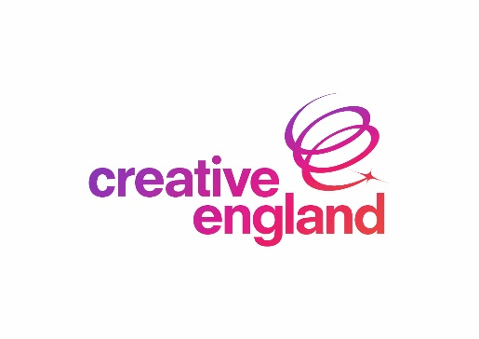

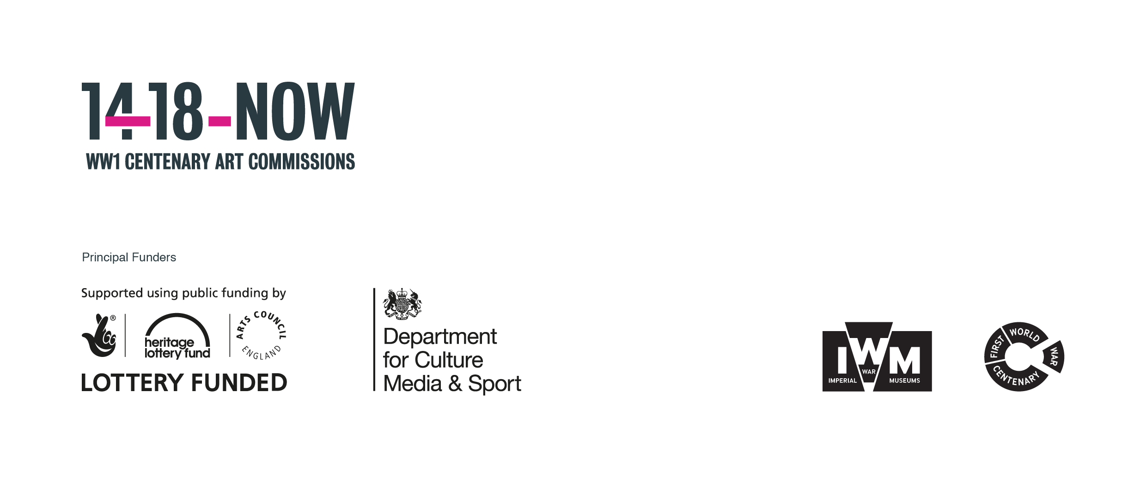

AIM: To create an immersive and experiential game/interactive content based around the events of the First World War

Background to the Project:

14-18 NOW is working with leading artists around the UK and internationally to commission new work in response to the First World War and the wider upheavals and developments of 1914-18.

Perceptions of the First World War have been shaped to a great extent by the artists of the time – the musicians, poets, writers, painters, photographers, and film-makers who reflected on the war and its effects on individuals and society. One hundred years later, the aim is to invite contemporary artists to look afresh at the First World War and the wider social, political, scientific and technological developments of the period and their impact over the century that followed and the world around us today.

The Cultural Programme will centre around three key moments: summer 2014 (anniversary of declaration of war), spring/summer 2016 (Battle of the Somme) and autumn 2018 (centenary of the Armistice).

Platforms:

The target platform is mobile and tablet devices (Primarily iOS and Android) but we also encourage applicants to consider PC distribution via Steam and as a direct download from the 14-18 NOW website (where applicable).

Project Objective:

- To invite the creative industries to reflect on the First World War from the perspective of today alongside other contemporary artists.
- To co-commission a new and original game/interactive content that will respond to the First World War and the developments of the period around the world stimulated by the conflict.
- To engage young people in interesting and unexpected stories from the First World War without taking the form of an education project.

Possible points of departure:

Applicants are encouraged to think broadly about the First World War and beyond the traditional ‘war game’ format and consider themes such as, but not limited to:

- Global reach/impact of the First World War
- New technological developments that came about because of the war.

Style of the Game/interactive content:

An innovative interactive experience with a strong gaming element that is easy to use and accessible. There is potential for character-based gameplay or for it to take the form of a quest or RPG. The tone should be thought provoking or surprising and attempt to present a new perspective of elements from First World War conflict, rather than a narrative of battles.

A key requirement of the commission is for games designers to collaborate with an artist in another art form such as a writer, visual artist, animator, musician or another creative input to add to the development of the game.

Game developers will be expected to draw on First World War themes and can access the IWM collections and archive for background.

Desired Outcomes:

An innovative and absorbing gaming/interactive content experience that offers a new perspective to an element of the First World War and encourages sharing comparisons of the game or discussion between peers.

There should be opportunities to create thought provoking situations and encourage interactive decision making.

Original use of control mechanics and user interface to create a resonating and thoughtful interactive experience will be an important design consideration.

Distribution:

Game/interactive content to be available as widely as possible across multiple platform App Stores and online distribution.

We invite business case propositions that are for either a Free-to-Play title designed to allow for additional paid-for follow-up in-game content or as premium upfront purchase product.

Budget:

The game/interactive content is a co-commission between 14-18 NOW and Creative England.

The game/interactive content can be based on an existing underlying framework or technology that the company has experience of or has used on previous commercial releases.

The total budget of your proposal should not exceed £82,000.

More information:

If you have any questions about the 14-18 NOW programme please contact Sud Basu, Producer on 0207 091 3053 or email sud.basu@1418now.org.uk.

